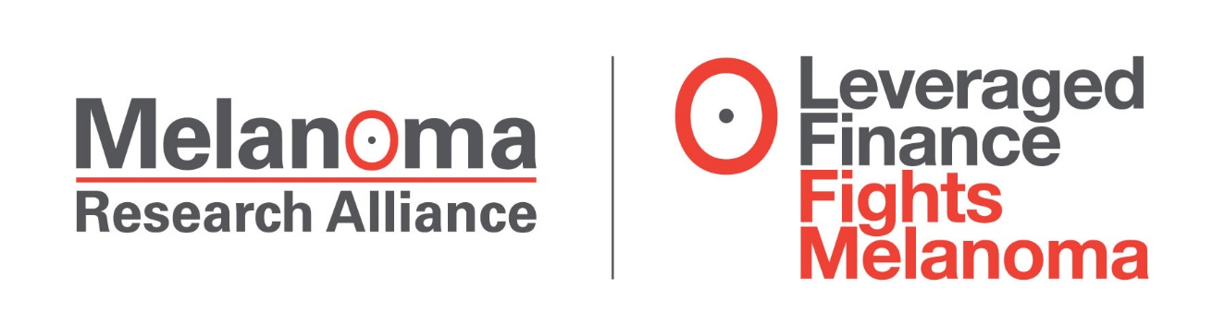
Leveraged Finance Industry Raises $1.8 million
at Sixth Annual Melanoma Benefit
----
Over 1,000 gathered at New York City’s Rockefeller Center: The Summer Garden

New York, NY, May 25, 2017 – Over 1,000 professionals from the leveraged finance community gathered yesterday for the sixth annual Leveraged Finance Fights Melanoma (LFFM) benefit and cocktail party raising a record $1.8 million in funds for the Melanoma Research Alliance (MRA), the largest private funder of melanoma research.
The annual event raises critical funds for melanoma research and awareness on skin cancer prevention. Founded in 2011 by Jeffrey Rowbottom of PSP Investments and Brendan Dillon of UBS—both of whom combatted melanoma— LFFM events have previously raised more than $6.8 million to support MRA’s global research programs. While the Melanoma Research Alliance awards $8-10 million each year, the LFFM raises 15- 20% of that year’s funding alone, proving to be an invaluable source of revenue for research.
“This event plays a critical role, not only to raise money that truly impacts the oncology field, but also to educate people on a disease that in most cases is preventable,” says LFFM Co-Chair, Jeffrey Rowbottom.
Because prevention is key to lowering the risk of being diagnosed, attendees were encouraged to sign up for a skin check pledge, committing to have their skin examined by a dermatologist within 6 months. For each person taking the skin check pledge, L'Oréal Paris had committed $100 per sign up, up to $250,000 for 2017. L'Oréal Paris is a featured partner of the Melanoma Research Alliance, committed to supporting research. To date, L'Oréal Paris has promised to fund $1.5 million in grants.
LFFM was chaired by Brendan Dillon of UBS; Lee Grinberg of Elliott Management; George Mueller and Cade Thompson of KKR; Jeff Rowbottom of PSP Investments; and Trevor Watt of Hellman & Friedman.
Over 87,000 Americans are expected to be diagnosed with melanoma in 2017, and incidence of the disease continues to rise. Thanks to research funded by MRA, treatment outlook for the disease has improved in recent years, yet further advances are needed to fully eliminate suffering and death related to melanoma.

About The Melanoma Research Alliance (MRA)
MRA is a public charity formed in 2007 under the auspices of the Milken Institute, with the generous founding support of Debra and Leon Black. MRA to date has dedicated more than $88 million to research seeking to better prevent, diagnose, and treat melanoma. Due to the ongoing support of its founders, 100% of every dollar MRA raises goes directly to funding melanoma research. The organization is poised to build on recent momentum in the field, accelerating the pace of scientific discovery and translation in order to eliminate suffering and death due to melanoma. MRA’s ability to fund wide-ranging research in melanoma is amplified by unique multi-faceted collaborations with individuals, private foundations and corporations.
For more information on MRA, visit www.CureMelanoma.org.
###
Contact: Melanoma Research Alliance
202.336.8922
Pamela Goldsmith -- pgoldsmith@curemelanoma.org

Anreder & Company
212.532.3232
Steven S. Anreder -- steven.anreder@anreder.com
Michael Wichman -- michael.wichman@anreder.com

